**Project Design Phase-II**

**Data Flow Diagram & User Stories**

|  |  |
| --- | --- |
| Date | 26 June 2025 |
| Team ID | LTVIP2025TMID59619 |
| Project Name | Shopez : one-stop shop for online purchases |
| Maximum Marks | 4 Marks |

**Data Flow Diagrams:**

A Data A Data Flow Diagram (DFD) illustrates how data flows through the Shopez e-commerce platform. It captures interactions between users (customers, sellers, admins), internal processes (product browsing, order placement, payment processing, messaging), and data storage .

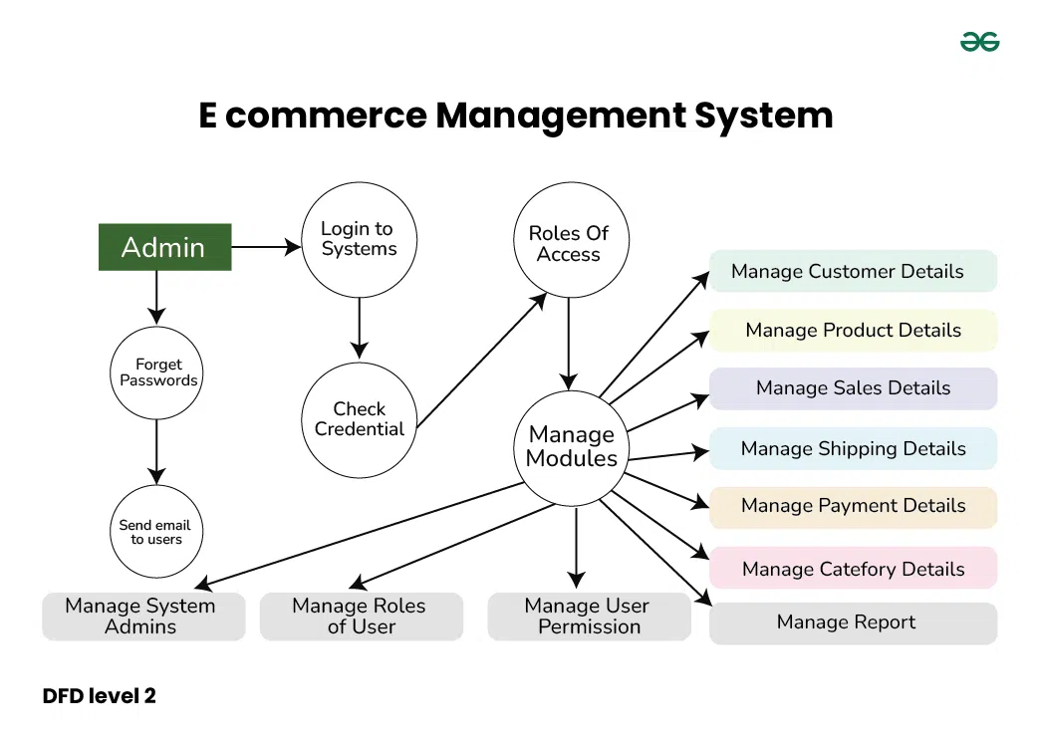

**User Stories**

**User Story Table – Shopez**

|  |  |  |  |  |  |
| --- | --- | --- | --- | --- | --- |
| **User Type** | **Functional Requirement (Epic)** | **User Story / Task** | **Acceptance Criteria** | **Priority** | **Release** |
| **customer**   |  | | --- | |  | | |  | | --- | | Product Browsing & Search | | As a customer, I can search and filter products by category, name, and price range. | Products returned match filters correctly. | High | Sprint-1 |
| **customer** | Product Details | As a customer, I can view detailed information and images for a product. | |  | | --- | | Product details load correctly with images and descriptions. |  |  | | --- | |  | | High | Sprint-1 |
| |  | | --- | | **customer** |  |  | | --- | |  | | |  | | --- | | Cart & Order Management |  |  | | --- | |  | | |  | | --- | | As a customer, I can add or remove items from my cart. | | |  | | --- | | Cart updates reflect immediately with correct total price. |  |  | | --- | |  | | High | Sprint-2 |
| **seller** | Seller Dashboard & Inventory | As a seller, I can upload new products with images, prices, and stock info. | Product is listed and visible to customers. | Medium | Sprint-3 |
| **Customer** | Order Management | As a seller, I can view and manage incoming orders. | Orders are displayed in seller dashboard with order status. | High | Sprint-3 |
| **customer** | Product Reviews | As a customer, I can leave a review after receiving a product. | Review is saved and visible under product. | High | Sprint-3 |
| **Admin** | |  | | --- | |  |  |  | | --- | | User Moderation | | As an admin, I can manage users and disable suspicious accounts. | Actions logged and reflected on user accounts. | Medium | Sprint-4 |
| **Customer/Seller** | Messaging | As a user, I can message other users regarding an order or product. | Messages appear instantly and are stored in conversation history. | High | Sprint-4 |